Problem Approach

* The project began with the creation of HTML templates to define the structure and layout of the web application with the help of bootstrap.
* Once the HTML templates were in place, next the SQLite database models were defined to represent the data structure and relationships within the application.
* The next step involved writing the Flask for the application code for the CRUD operations of the application.
* Additional features were added and also the testing of the application for errors bring the completion of the project.

About The Library Management System

* It is a hosted web application using flask application code.
* Uses Jinja2 templates and Bootstrap for HTML generation and styling.
* SQLite database is used for storing the data.
* The application is a multi-user app (one admin/librarian and multiple general users) where the user can request, read and return book.
* Librarian/Admin can add new sections/e-books, issue/revoke access for a book.

Database Model (Entity Relationship Diagram) of the project

* 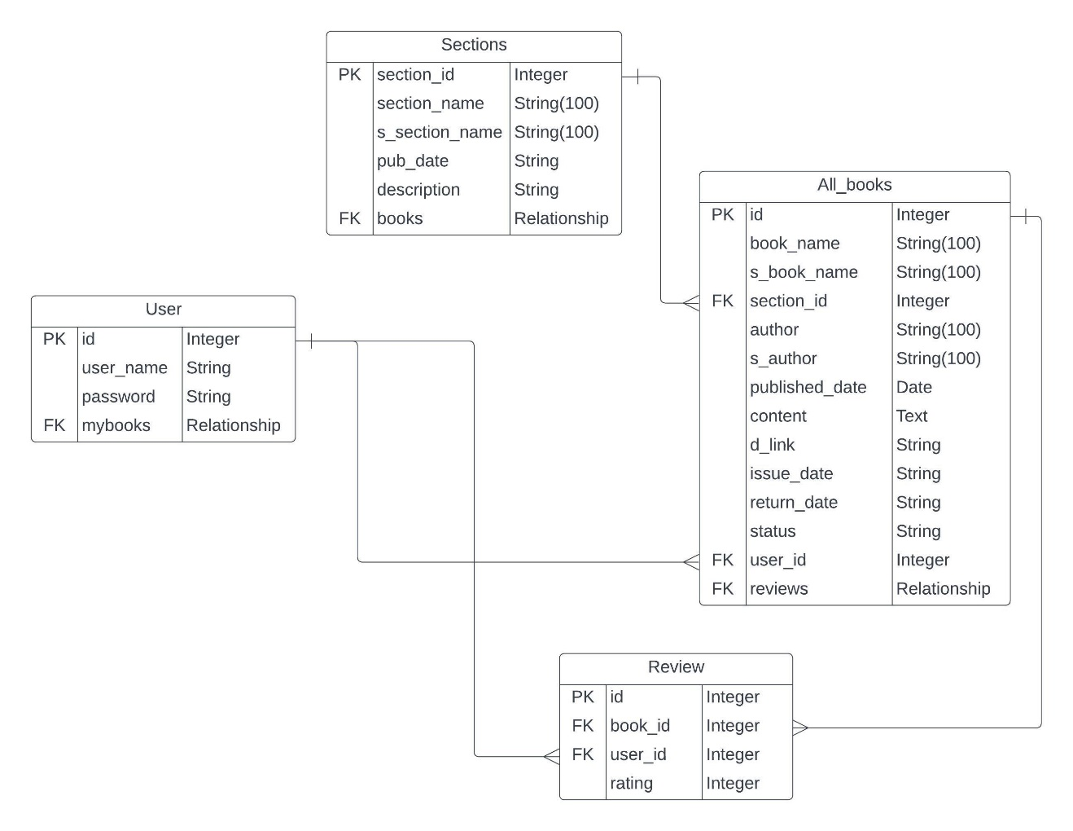Below ER diagram specify the database models and their relations.

File Management of the Project

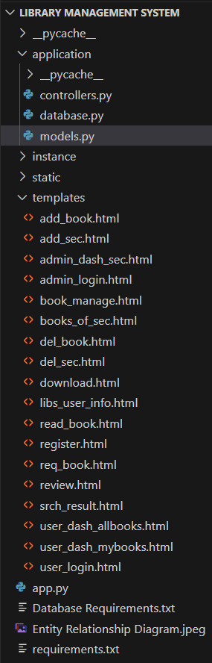

* The **controllers.py** contains all the endpoints of the web application, and contains most of the back-end code. Rest of it are distributed between ***models.py*** (defines the tables for SQLAlchemy classes), ***database.py*** (hooks up the database to models.py).
* The ***static*** folder contains the CSS stylesheets which are used in the design of the webpages of the application.
* Application may store instance-specific data such as local databases, logs, or other persistent data files within the **instance** folder.
* The **templates** folder contains HTML files that serve as templates for rendering web pages as shown above in the attached picture.

Submitted By :-

**Aditya Ambati**

Email:- [21f3000274@ds.study.iitm.ac.in](mailto:21f3000274@ds.study.iitm.ac.in)

For a walkthrough of my project check this [video](https://drive.google.com/file/d/1ORjXY-YtZFuy8qo5XPOOotcJyO_ldf8Y/view?usp=sharing).